**A PROJECT REPORT ON**

**“Eye-Tracking Virtual Mouse”**

**SUBMITTED IN PARTIAL FULFILLMENT OF THE REQUIREMENTS OF DEGREE OF**

**BACHELOR OF ENGINEERING BY**

**Vishwesh Chavan (BE_A_15)**

**Rushikesh Jadhav (BE_A_39) Shreyas Jadhav (BE_A_40)**

### SUPERVISOR

**Ms. Pooja Patil**



### DEPARTMENT OF COMPUTER ENGINEERING

**PILLAI HOC COLLEGE OF ENGINEERING AND TECHNOLOGY, PILLAI'S HOC EDUCATIONAL CAMPUS, HOCL COLONY, RASAYANI, TAL: KHALAPUR, DIST:RAIGAD410207**

**UNIVERSITY OF MUMBAI [2023-24]**

## Mahatma Education Society’s Pillai HOC College of Engineering and

**Technology, Rasayani - 410207**

**[2023-24]**

**Certificate**

This is to certify that the Major Project-I entitled “**Eye-Tracking Virtual Mouse”** is a bonafide work of **Vishwesh Chavan, Rushikesh Jadhav, Shreyas Jadhav** submitted to the University of Mumbai in partial fulfillment of the requirement for the award of the degree of **“Undergraduate”** in **“Computer Engineering”.**

### Ms.Pooja Patil

(Supervisor)

### Dr. Rajashree Gadhave

(Project Coordinator)

### Ms. Rohini Bhosale

(Head of Department)

### Dr. J. W. Bakal

(Principal)

# Project Report Approval for B.E

This project report entitled “**Eye-Tracking Virtual Mouse”** submitted by **“Vishwesh Chavan, Rushikesh Jadhav, Shreyas Jadhav”** is approved for the degree of **Bachelor of Engineering in Computer Engineering**.

### Examiners

1.

2.

**Date Place:**

# Declaration

We declare that this written submission represents our ideas in our own words and where others ideas or words have been included. We have adequately cited and referenced the original sources. We also declare that we have adhered to all principles of academic honesty and integrity and have not misrepresented or fabricated or falsified any idea/data/fact/source in our submission. We understand that any violation of the above will because for disciplinary action by the Institute and can also evoke penal action from the sources which have thus not been properly cited or from whom proper permission has not been taken when needed.

**Vishwesh Chavan**

**Rushikesh Jadhav**

**Shreyas Jadhav**

**Date:**

*Effective cross-language communication is crucial in the linked world of today. TextBridge, a modern PDF language translation application, provides a full answer to this problem. In an increasingly connected world, this gadget is especially made to help people communicate effectively across language barriers. TextBridge provides a creative response to the issues raised by the transmission of information across several languages, with a heavy emphasis on PDF document translation.TextBridge's compatibility with PDF files is one of its primary advantages. By enabling users to work directly with PDF files, this initiative hopes to streamline the translation process by doing away with the necessity for laborious manual text extraction. Given that PDF files are among the most widely used formats for exchanging textual information, this is a considerable advantage.This inclusiveness encourages intercultural understanding and eliminates linguistic barriers in a variety of fields, including business and academics.TextBridge uses cutting-edge machine translation technology to guarantee translation accuracy and contextual relevance.Effective communication requires algorithms that can preserve the details and meaning of the original text.Another essential component of TextBridge is usability. The project's user interface is simple to use and open to a wide range of users, including small and major businesses. The ease with which PDF files can be uploaded, target languages can be chosen, and translations can be started all contribute to a better user experience.TextBridge stands out due to its offline mode.The translation process may go without interruption even in difficult network circumstances thanks to its offline mode*

*.In conclusion, TextBridge is a revolutionary initiative that enables people, companies, and organizations to overcome linguistic obstacles. It encourages diversity, accessibility, and interconnectedness and might transform the way we think about multilingual communication. In a world where effective communication is crucial, TextBridge has the ability to dissolve language barriers and encourage cross-cultural understanding and collaboration whether it is for business papers, academic research, legal contracts, or interpersonal interactions.*

***Keywords****: PDF Language Translator ,Multilingual communication, Cross-cultural understanding, Compatibility with PDF files, Offline mode*

1. PLTT - PDF Language Translation Tool
2. PDF-LT - PDF Language Translator

**Figure No.**

**Figure Name Page**

**No.**

|  |  |  |
| --- | --- | --- |
| Figure 3.1 | Gantt Chart | 25 |
| Figure 4.1 | DFD | 27 |
| Figure 4.2 | Use Case Diagram | 27 |
| Figure 4.3 | Sequence Diagram | 28 |
| Figure 5.1 | State Transition Diagram | 30 |
| Figure 5.2 | Swim Lane Diagram | 31 |
| Figure 6.1 | System Architecture | 34 |
| Figure 6.2 | Methodology | 36 |

**Table No.**

**Name of Table Page**

**No.**

Table 3.1 Gantt Chart 25

### TABLE OF CONTENTS

**Content Page No.**

**Abstract i**

**Abbreviations ii**

**List of Figures iii**

**List of Tables iv**

1. **Introduction 1**
   1. Background 2
   2. Motivation 2
   3. Organization of the report 2
2. **Literature Survey 3**
   1. Fundamental Concepts 4
   2. Existing Systems 4
   3. Problem Statement 5
   4. Scope of the Project 6
3. **Planning and Requirement Gathering 8**
   1. Software and Hardware Requirements 9
   2. Project Plan (Gantt chart) 10
   3. Cost Estimation 11
4. Project Analysis 24
   1. Data Flow Diagram 25
   2. Use Case Diagram 25
   3. Sequence Diagram 26
5. Project Design 27
   1. State Transition Diagram 28
   2. Swim Lane Diagram 29
6. Proposed System 21
   1. Proposed System Architecture 22
   2. Methodology 22
7. Conclusion 36

References 38

# Chapter 1 Introduction

Pillai HOC College of Engineering and Technology ,Rasayani

11

## Background

Eye tracking technology can be a valuable assistive technology tool for people with conditions like amyotrophic lateral sclerosis (ALS), spinal cord injuries, or muscular dystrophy. It allows them to control and navigate digital interfaces, communicate, and perform tasks that were previously difficult or impossible. Eye tracking technology can be used for medical and rehabilitative purposes. For instance, it can aid in diagnosing certain neurological and ophthalmic disorders by tracking eye movement patterns and identifying abnormalities. It can also be used in post-stroke rehabilitation to help patients regain control of their gaze and improve eye-hand coordination.

## Motivation

Eye tracking technology can provide a valuable tool for individuals with disabilities, particularly those who have limited or no use of their hands. This technology allows people to control a computer or interact with digital devices using their eyes, opening up new possibilities for those who might otherwise struggle with traditional input methods. Developing eye tracking technology and incorporating it into a virtual mouse project represents an opportunity to push the boundaries of human-computer interaction. It's a fascinating area of technological innovation that can lead to new breakthroughs and applications. the motivation behind an eye tracking virtual mouse project is to improve accessibility, enhance the user experience, enable hands-free interaction, drive innovation, and cater to the needs of various user groups, all while leveraging the capabilities of eye tracking technology for a wide range of applications.

## Organizations of Report

Chapter 1: Introduction The chapter introduces the report by providing some background information on the project and its relevance. The first section, briefly discusses the project and it purpose. The second section, explains why the project is important and how it can benefit the intended users.

Chapter 2: Literature Review This chapter provides an overview of the existing literature related to the Cyber Attack Detection. It also presents the problem statement and outlines the goals and objectives of this project.

Chapter 3: Requirement Gathering The requirement gathering chapter describes the process of identifying and documenting the requirements for the project. The software and hardware requirement section of the requirement gathering chapter describes the specific software and hardware requirements.

Chapter 4: Plan of the project The plan of the project chapter describes the overall plan and approach for developing the system. This includes outlining the methodology that will be used to develop the system, creating a project plan that outlines the timeline for completing each phase of the project, and presenting the proposed system architecture

Chapter 5: Project Analysis The Chapter 5 of the project report is focused on project analysis which includes various diagrams to better understand the system's architecture and functionality. Chapter 6: Project Design This chapter provides a detailed design for the project. It includes two important diagrams, the Data Flow Diagram (DFD) and the Flow Chart**.**

# Chapter 2

**Literature Survey**

Pillai HOC College of Engineering and Technology ,Rasayani

### Fundamental Concepts

* + 1. Eye Tracking Technology: Learn the basics of how eye tracking technology works. Eye trackers use infrared light to track the movement of your eyes, capturing data about where you're looking and the position of your gaze.
    2. Calibration: Calibration is the process of mapping the eye tracker's measurements to specific points on a display. It's crucial to ensure accurate tracking, as individual variations in eye anatomy and head position can affect the results.
    3. Gaze Data: Eye tracking systems provide gaze data, which includes the x and y coordinates of where the user is looking on the screen. This data is essential for controlling a virtual mouse.
    4. Input Devices: Consider the type of input devices you will use to control the virtual mouse. Common options include traditional computer mice, keyboards, or specialized controllers designed for eye tracking.
    5. Software Development: You'll need to develop software that interprets gaze data and translates it into mouse movements on the screen. This software should be capable of controlling the mouse pointer, clicking, and performing other mouse-related functions.
    6. User Interface Design: Design a user-friendly interface for controlling the virtual mouse using eye movements. Think about how users will interact with the system, including actions like selecting, dragging, and dropping.
    7. Accessibility: Eye tracking technology can be a valuable tool for individuals with disabilities. Ensure that your virtual mouse project is accessible and user-friendly for people with different needs.

### Existing system

This is the software responsible for emulating a mouse cursor on the screen based on the user's eye movement. It receives data from the eye-tracking software and moves the cursor accordingly. Several commercial and open-source solutions are available for creating a virtual mouse system to ensure accurate eye tracking, users typically need to perform a calibration process. During calibration, the software prompts the user to focus on specific points on the screen to create a mapping between their gaze and screen coordinates. This improves the accuracy of the system.The system emulates the movement of a traditional mouse cursor. Users control the cursor's position by moving their eyes, and in some cases, blinking or other eye gestures can be used to simulate mouse clicks.

### Problem Statement

Develop a system that utilizes eye tracking technology to create a virtual mouse control interface, allowing users to interact with computers and digital devices by moving and clicking the cursor through eye movements. The project should address the challenges of accurate and intuitive eye tracking, minimize user fatigue, and ensure compatibility with various operating systems and applications. The goal is to provide a hands-free and more accessible alternative to traditional mouse input methods, particularly for individuals with physical disabilities or those seeking a novel and efficient way to interact with digital interfaces.For practical use, the virtual mouse system should work with various applications, including web browsers, text editors, and productivity software. It should be able to click, scroll, and perform other mouse-related actions.

### Scope of the Project

"TextBridge-PDF Language Translator Tool," the project that is being suggested, aims to create an integrated system that combines TextBridge's OCR capabilities with a powerful language translation tool. The goal of this project is to make it easier to translate PDFs and scanned documents into different languages, all the while preserving the formatting and organization of the original text. The project is to offer a comprehensive solution for effective document translation, meeting a range of user demands and promoting international communication and information sharing with a user-friendly interface and support for many languages.

# Chapter 3

**Planning and Requirement Gathering**

### Software and Hardware Requirements

Here we will discuss everything we will need in order to execute. Below we list the necessary hardware and software requirements.

### Software Requirements:

* + - 1. Python: The core programming language for developing the project. Python should be installed on the system, and the project may specify a minimum Python version.
      2. Python Libraries: Various Python libraries and modules for tasks such as file handling, machine learning, and user interface development. Common libraries include TensorFlow, scikit-learn, hashlib, and PyQt for the graphical user interface.
      3. IDE (Integrated Development Environment): An IDE like PyCharm, Visual Studio Code, or Jupyter Notebook for coding and project development.
      4. Operating System: The project should specify compatibility with specific operating systems, such as Windows, macOS, or Linux.
      5. Version Control: A version control system like Git for collaborative development and tracking changes.

### Hardware Requirements:

* + - 1. Processor (CPU):A modern multi-core processor (e.g., Intel Core i5 or higher) is sufficient for most development tasks.
      2. Memory (RAM):At least 8GB of RAM is recommended for handling medium-sized datasets and NLP tasks. More RAM may be required for larger datasets and complex models.
      3. Storage:Adequate storage space for storing datasets and any database systems you plan to use.

### Project Plan (Gantt chart)

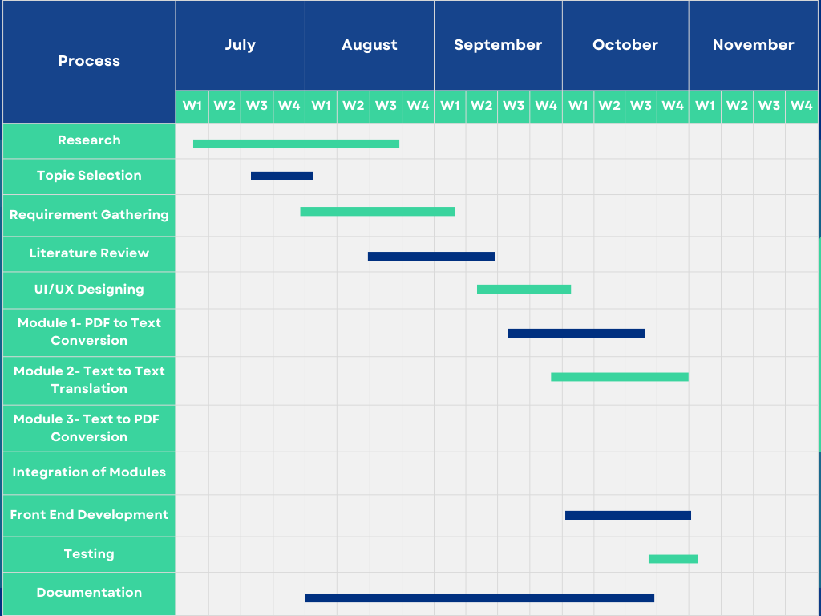

Table 3.1:- Gantt chart

### Cost Estimation

Hardware: O.S

Software: Extraction and Translations tool resources

# Chapter 4 Project Analysis

### Data Flow Diagram

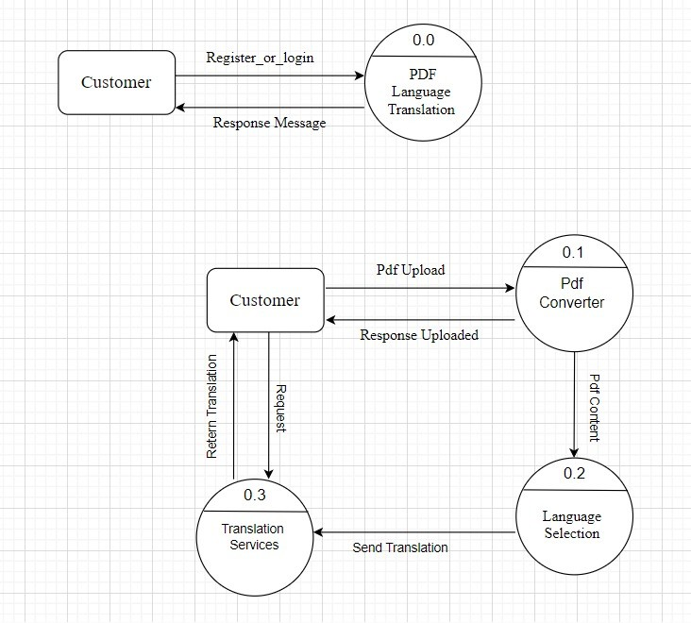

### Use Case Diagram

Fig 4.1:- DFD

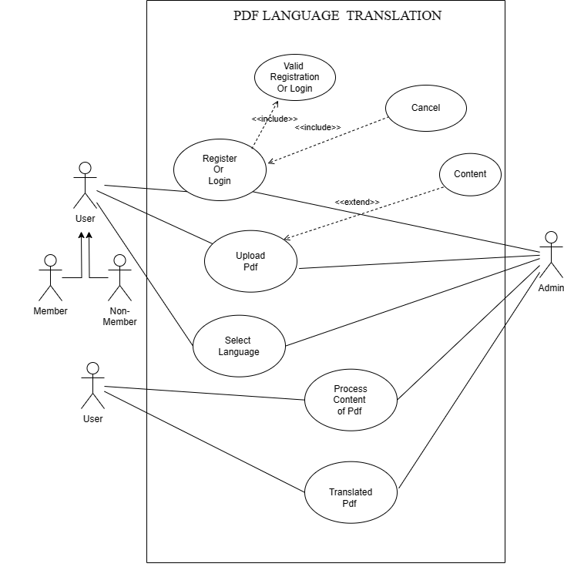

Fig 4.2:- Use Case Diagram

### Sequence Diagram

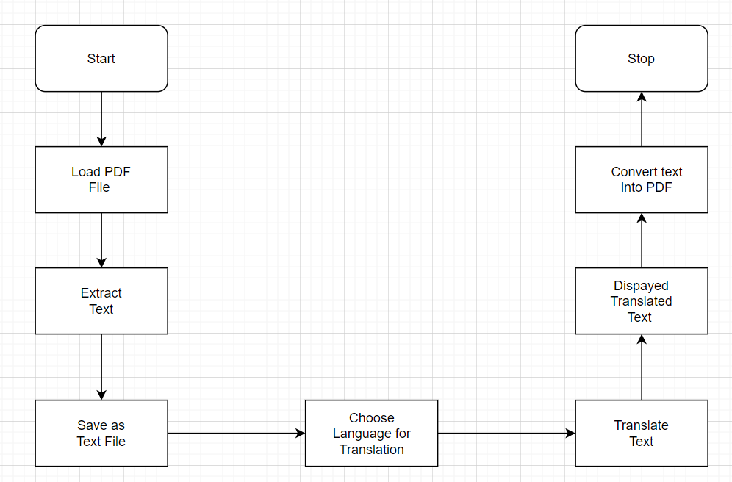

Fig 4.3:- Sequence Diagram

# Chapter 5 Project Design

Pillai HOC College of Engineering and Technology, Rasayani24

### State Transition Diagram

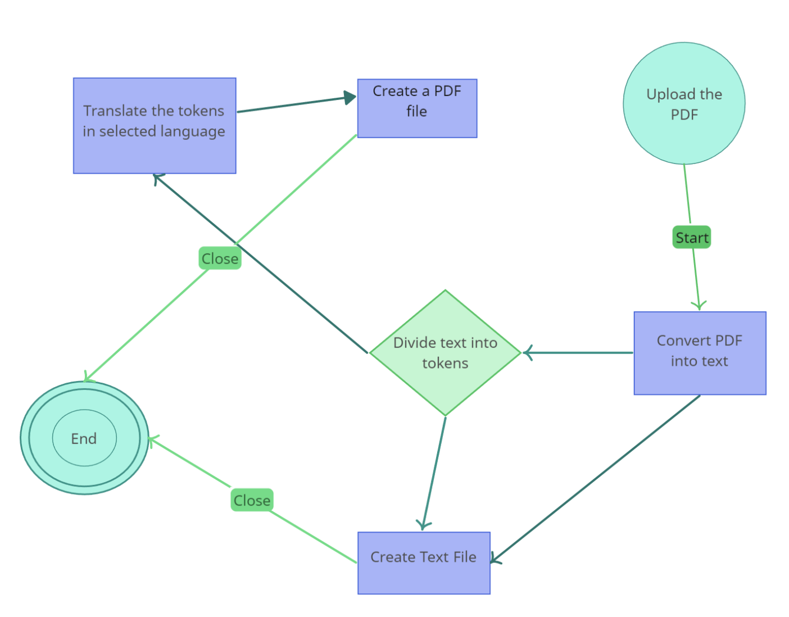

Fig 5.1:- State Transition Diagram

### Swim Lane Diagram

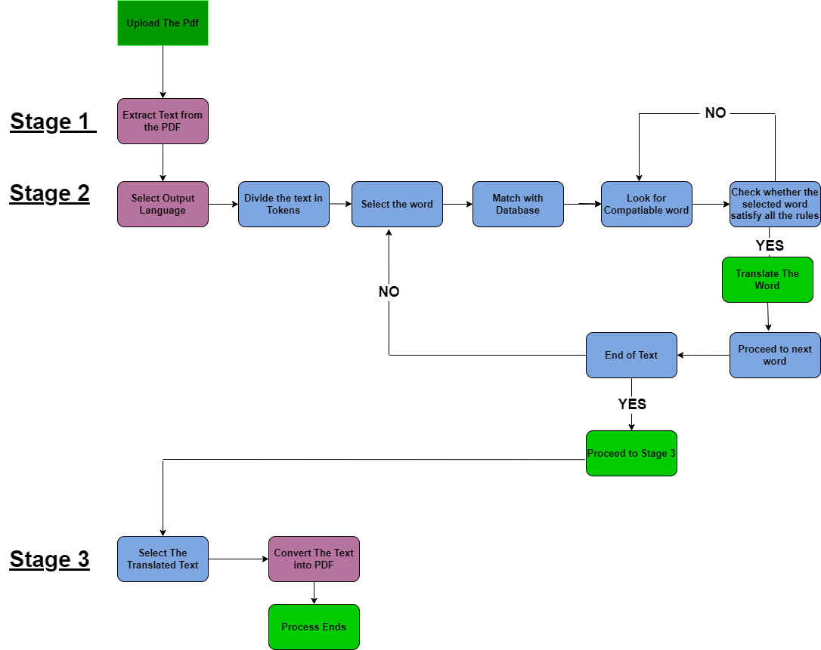

Fig 4.1:-Swim Lane Diagram

# Chapter 6 Proposed System

### Proposed System Architecture

* + 1. User Interface: An intuitive interface simplifies user interaction, while multilingual support allows for seamless translation in diverse languages.
    2. Text Processing: The system efficiently extracts and cleans text from PDFs, preparing it for accurate translation.
    3. Translation Engine: A robust integration with a reliable translation service facilitates accurate language translation, supporting various language pairs.
    4. Formatting and Reconstruction: The tool ensures that the original PDF layout is maintained while fitting translated text appropriately, preserving document integrity.
    5. Quality Control: Stringent quality checks are implemented to ensure the accuracy and coherence of the translated content, with a user feedback mechanism for continual improvement.
    6. Security Measures: Strong encryption protocols safeguard the confidentiality of documents during both processing and transmission, ensuring data privacy.
    7. Performance Optimization: The system is optimized for efficient and rapid translation processing, with a scalable architecture capable of handling large volumes of documents.

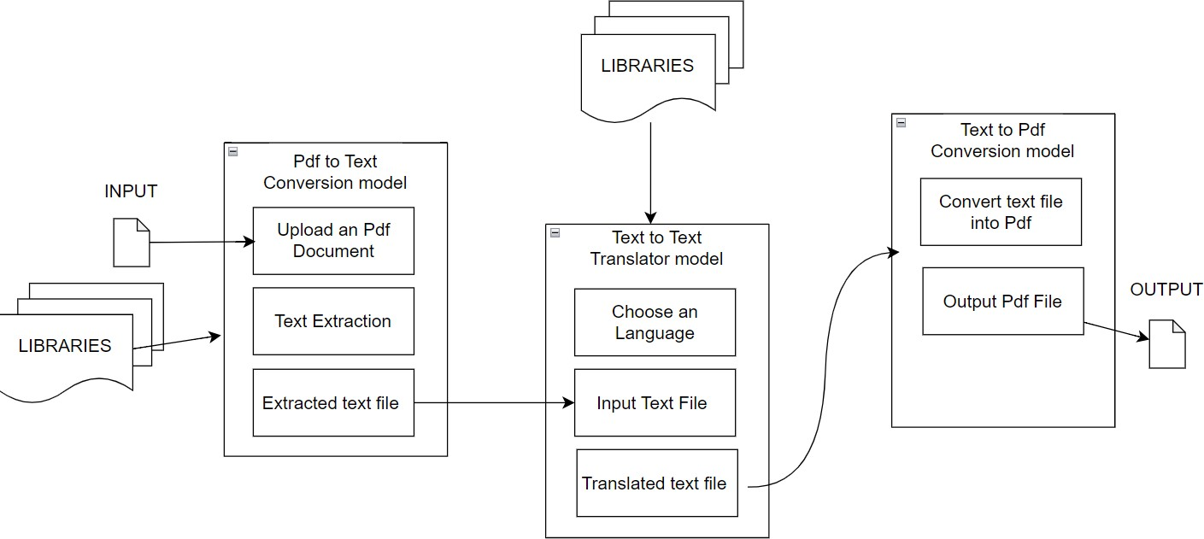

Fig 6.1:- System Architecture

### Methodology

Certainly, here is a succinct breakdown of the methodology:

* + 1. Market Research and Analysis:Conduct in-depth market research to understand user preferences and demands for PDF translation tools.Analyze existing solutions to identify gaps and opportunities for improvement.
    2. Requirement Gathering: Engage with stakeholders to gather specific functional and non-functional requirements for the PDF language translation tool.Prioritize requirements based on user needs and technical feasibility.
    3. Technology Selection: Evaluate and select the most suitable technologies for PDF parsing, language translation, and document formatting.Assess the compatibility of different technologies for seamless integration.
    4. System Design and Architecture: Design the system architecture, ensuring scalability and flexibility to accommodate future enhancements.Develop a comprehensive plan for data flow, security, and user interface design.
    5. Prototype Development: Create prototypes to visualize the user interface and workflow, incorporating feedback from potential users.Refine the prototype iteratively to enhance user experience and functionality.
    6. Core Development: Implement PDF parsing algorithms to extract and process text from PDF documents.Integrate a powerful and accurate language translation engine, considering multilingual support and translation accuracy.
    7. Testing and Quality Assurance: Conduct thorough testing to ensure accurate translations and proper preservation of the original document format.Perform quality checks to verify the tool's reliability, performance, and security measures.
    8. Deployment and Integration: Deploy the tool on a secure and reliable infrastructure that supports the expected user load.Integrate the tool with various platforms and systems to enhance accessibility and usability.
    9. User Training and Support: Provide comprehensive user training materials, including tutorials and documentation, to facilitate seamless adoption of the tool.Establish a dedicated support system to address user queries and provide timely assistance

.

* + 1. Continuous Improvement and Maintenance: Gather user feedback to identify areas for improvement and future feature enhancements.Regularly update the tool to adapt to evolving user needs, technological advancements, and security requirements

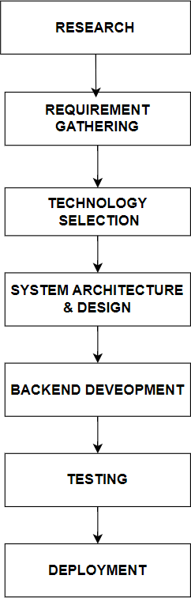

Fig 6.2:- Methodology

# Chapter 7 Conclusion

### Conclusion

In conclusion, the development of TextBridge, a PDF language translation tool, represents a significant stride in bridging language barriers and enhancing cross-cultural communication. By seamlessly integrating advanced PDF parsing, robust translation engines, and meticulous document formatting, TextBridge offers users a comprehensive solution for accurately translating PDF documents while preserving their original layout and structure. With a user-friendly interface, robust security measures, and continuous support and updates, TextBridge stands as a reliable and efficient tool, catering to the diverse language translation needs of a global user base. As the digital landscape continues to evolve, TextBridge remains committed to staying at the forefront of innovation, ensuring that users can effortlessly navigate the multilingual world with confidence and ease.

Pillai HOC College of Engineering and Technology, Rasayani37

# References

1. <https://ieeexplore.ieee.org/abstract/document/8776778/>
2. [www.slideshare.net/SumitSumit26/language](http://www.slideshare.net/SumitSumit26/language)
3. <https://www.adobe.com/acrobat>
4. Purnima Tomar, Prateek Arora, Aakash Goel, Dharmender Saini, Social Profile Based Gift Recommendation System, International Journal of Computer Science and Information Technology. Vol.5(3), 2014, 3670-3673. [5]https://[www.researchgate.net/publication/262322986_The_Spoken_Language_T](http://www.researchgate.net/publication/262322986_The_Spoken_Language_T) ranslator

Pillai HOC College of Engineering and Technology, Rasayani40